

Contents

1 Introduction 3

2 PR19 Resilience 3

2.1 Systems based approach 3

2.2 Operational resilience 4

2.3 Financial resilience 5

2.4 Corporate resilience 5

2.5 Line of sight 6

3 Action Plan 8

3.1 Revising our systems-based approach to resilience 8

3.2 Maturity assessment 9

3.3 Interdependencies analysis 9

3.4 The Cabinet Office 4 R’s of resilience 9

3.5 Understand & identify the shocks & stresses 10

3.6 Line of sight 10

3.7 Assurance 10

3.8 How are we going to get there 11

3.9 Future plans 11

3.10 Project plan 12

3.11 Programme (indicative) 13

# Introduction

Portsmouth Water is committed to our vision of “doing the right thing for customers, the environment and the region in which we operate” this has been demonstrated over several decades.

We operate on the edge of the South East England region, which is facing long term challenges in relation to water resources - including climate change, population growth and more extreme weather events. To achieve our vision, Portsmouth Water has to be customer driven, have resilient water resources, assets, and corporate & financial systems.

To maintain this vision and resilience requires us to have the right corporate leadership and culture. This is very much driven by the Board of Directors who are responsible for assuring good governance and corporate resilience. As might be expected, there are “Matters reserved for the Board” and these include responsibility for activities and decisions that are necessary to ensure the resilience of the Company in the round.

PR19 Resilience

## Systems based approach

We recognise that our approach, whilst considerably improved from historic business plans, is not in line with the expectations of Ofwat in terms of an integrated systems-based approach. We do feel that we have a very good understanding of resilience within the three areas of operational, financial and corporate resilience, however the system understanding and interdependency between these areas could be improved.

As part of our work in preparation for PR19 Portsmouth Water has identified 12 systems within the business, many of which are interdependent. This work included an evaluation of the current and end of AMP level of resilience in each area.

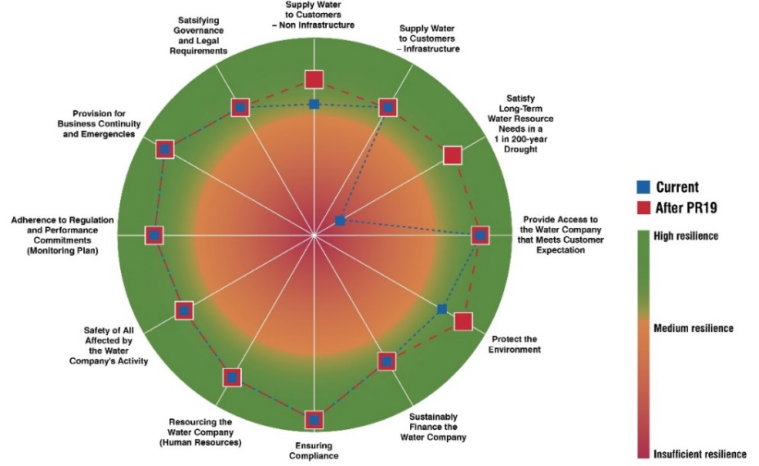

Portsmouth Water is fully committed to developing and implementing a systems-based approach to resilience in the round. This will ensure that the company can demonstrate in the future an integrated resilience framework that underpins the company’s operations and future plans. It will also show a clear line of sight between risks to resilience, planned mitigations, the package of outcomes and corporate governance.

## Operational resilience

Our production, storage and distribution system is already highly resilient with 99.7% of customers fed directly from service reservoirs, which on average hold 2 days water storage – twice the industry standard. In addition, Portsmouth Water’s strategic spine main, as shown in the following diagram, provides a highly interconnected system between our 20 or so sources allowing the transfer of water around the network and into any areas with an operational issue or shortage. This significantly reduces the likelihood of our customers experiencing an interruption to their supplies.

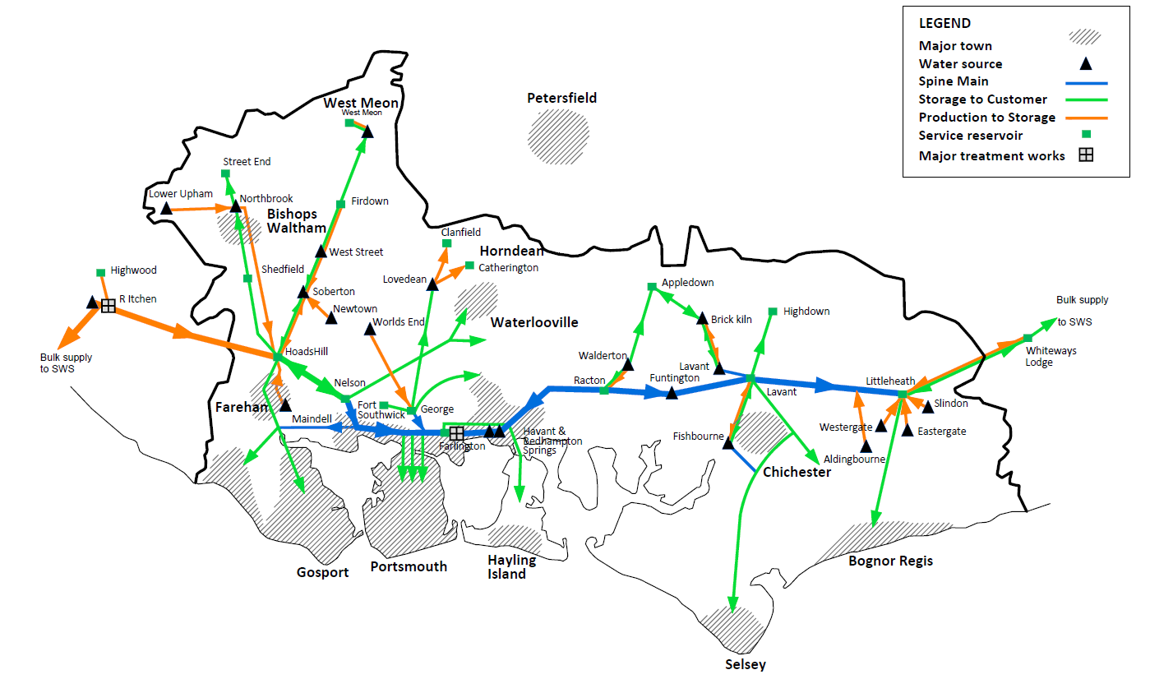

Whilst some water companies have recently developed grid systems at significant cost to improve the ability to transfer water around their areas, we have evolved our system historically, building in resilience over time to ensure our network can manage current and future demands. 60% of our network is pressure managed. This helps us reduce the likelihood of bursts, manage customer demand and remove excessive network pressures.

In preparation for PR19 we have worked closely with Servelec to develop a comprehensive system-based review and integrated view of our operational resilience. This has involved a complete review of the risks which we are aware of in our system as well as challenging our historic view to identified shocks and stresses previously not considered. We have considered an evaluation of the impact of single points of failure, during both peak and average demand conditions, and both multiple knock-on/cascading impacts and unrelated multiple failures across all operational assets. Importantly for our network, given the large amount of resilience provided by reservoir storage, the modelling looked at extended periods for events and how the system would perform.

The results of the study show that our operational system already has a high level of resilience:

* No properties are at risk of loss of supply from a single source of supply failure on an average demand day.
* 100,000 properties are at risk of loss of supply, for a proportion of the day, from a single source of supply failure on a peak demand day.
* 44 properties fed via boosters are at risk of loss of supply from a single source of failure on an average and peak day.

In response to our review of operational resilience we identified a number of mitigation schemes to lower the likelihood and impact of the risks which remain. Following analysis and customer research we plan to invest £2.5m in AMP7 to reduce the remaining risks by 86% and make our system even more resilient.

## Financial resilience

Financial resilience reflects our ability to avoid, cope with and recover from the financial impacts of business disruption. For PR19 we assessed financial resilience by undertaking financial modelling of a suite of scenarios, considering the extent to which the Company can reasonably avoid mitigate, and recover from such financial shocks.

These scenarios are based upon relevant severe, plausible and reasonable business scenarios. In setting the scenarios the Board reviewed in detail the Corporate Risk Register to identify appropriate operational scenarios.

We assessed, in our modelling, the impact on a range of metrics including the impact upon cash flow, financial ratios and key covenants. We have also considered and included within our modelling the ability of the business to mitigate such events including factors such as operational response & recovery, capital injections, borrowing facilities, insurance recovery, flexibility of operational spend and timing of dividend payments.

Having completed and reviewed our assessment of financial resilience, and the reasonableness of mitigations included, the Board concluded that the Company remains financially resilient.

## Corporate resilience

There are many factors that the Company considers which contribute to ensuring strong corporate resilience, these are proactively managed by the Company, led by the Board of Directors.

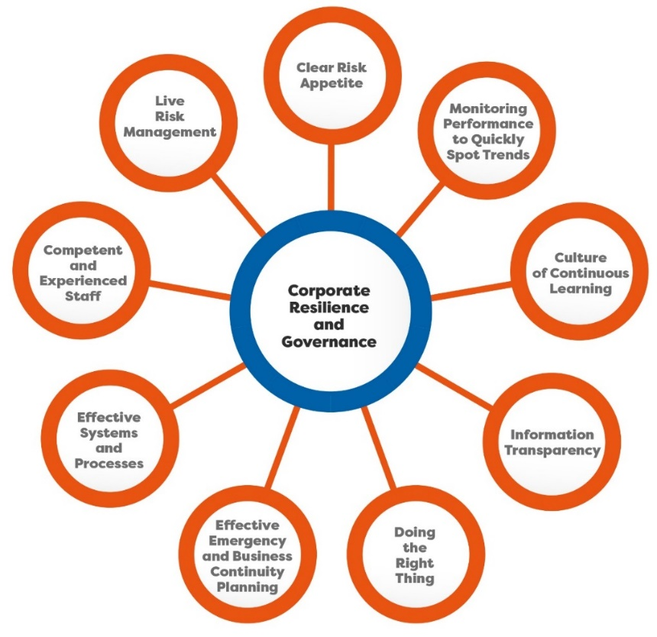

Active risk management has been embedded into the business, this provides the focal point for ensuring a level of resilience that is supported by customers (as highlighted above) and builds their trust in the company.

In recognition of the importance that active risk management has, the Board of Directors undertakes an annual assessment of risk to ensure that current and future risks are being managed to an acceptable level and that adequate controls are in place to manage risk. On a quarterly basis, the Board review all risks previously identified as requiring action and any changes to the risk register.

## Line of sight

One of Ofwat’s comments on our original plan is that we have not clearly shown a line of sight between risks to resilience, planned mitigations, packages of outcomes and corporate governance.

We have sought to clarify our approach in this area within our IAP submission as follows:

The operational resilience study which we have completed for AMP7 has identified a number of risk areas which we have addressed in our business plan. We have also included specific schemes to improve the resilience of certain parts of our strategic spine network and its ability to support the wider distribution system. The following table provides a line of sight between the risk areas identified in our resilience study and the ODI’s which will be used to monitor and measure our effective management of these risks.

We recognise that this work also need to include financial and corporate resilience and demonstration of a line of sight in these areas, which is an area we will develop as part of the action plan.



We recognise that this approach needs to align with the systems-based approach and will seek to implement a new way of doing this as part of our resilience action plan.

Action Plan

## Revising our systems-based approach to resilience

We recognise that Ofwat’s assessment of our PR19 submission on resilience has identified that we are not currently fully satisfying the requirement for a ‘systems-based approach to resilience’.

We recognise the importance of understanding our current level of resilience as a business and also the need to ensure that this is an integrated approach with all areas of the business considered.

We are fully committed to improving our performance in this area and bringing together our work on operational, financial and corporate resilience into an integrated systems-based approach to resilience in the round, which clearly demonstrates a line of sight between risks to resilience, planned mitigations, package outcomes and corporate governance.

We intend to review our current approach, in line with best practice and identify both the gaps in our plan as well as setting out an appropriate system and framework to work within in the future.

Our current system approach looks at 12 systems within the business, we will review this approach and the systems identified as well as the areas that these cover. An important part of this work will be to set out the definition and framework which identifies systems and how these fit within the 3 areas of operational, financial and corporate resilience to ensure that all areas are covered. Comparing our approach to Yorkshire Water’s submission (table below), which we understand was considered by Ofwat to be leading edge, where they have identified 16 systems in the water supply business, it is clear that they have approached this in a slightly different way than us, which we need to assess. We will also be improving our approach by sharing ideas and collaborating with other WOC’s.

|  |  |  |
| --- | --- | --- |
|  | **PW systems** | **Yorkshire systems** |
| Operational resilience systems | * Supply water to customers non infrastructure * Satisfy long term water resource needs in a 1:200 year drought | Water resources and collection |
| Water treatment and drinking water safety |
| Supply water to customers infrastructure | Water distribution |
| Provide access to the water company that meets customer expectations | Customer service |
| Protect the environment | Land management |
| Safety of all affected by the water companies actions |  |
| Financial resilience systems | Sustainably finance the water company | Business planning finance ability (short/medium term) |
| Long term viability planning |
| Financial transparency and reporting |
| Corporate resilience systems | Ensuring compliance |  |
| Adherence to regulation and performance commitments (monitoring plan) |  |
| Provision for business continuity and emergencies |  |
| Satisfying governance and legal requirements |  |
| Resourcing the water company (Human resources) | Human resource planning and management |
|  | Stakeholder management and communication |
|  | Enabling business support services |
|  | Supply chain management |
|  | Company strategy and horizon scanning |

## Maturity assessment

We propose to complete a maturity assessment on each system identified, following the guidance within BS65000 - Guidance on Organisational Resilience. The intention will be to establish how developed our approach is within each area and identify any gaps and deficiencies. Following this we will identify an improvement plan for each area. This is expected to be an iterative process; as the understanding of our systems and their interdependencies develops, so will the understanding of the maturity of our approach develop.

## Interdependencies analysis

Once we have completed the identification and initial assessment of the different systems the next piece of work will be to understand the interdependences of each system and how these interact and affect others. This will need to include all internal and external interdependencies and again will be an iterative process as knowledge and understanding develops.

## The Cabinet Office 4 R’s of resilience

In our original PR19 plan for resilience we considered the governments 4R’s of resilience approach.

|  |  |
| --- | --- |
| * Resistance * Reliability * Redundancy * Response & recovery   We will review all areas of our systems following this approach, including a review and feedback loop as we did in our previous approach. |  |

## Understand & identify the shocks & stresses

Part of the work we completed for PR19 was to independently identify the shocks and stresses which could impact operational, finance and corporate resilience. This work did not clearly follow a standard process for the business.

We are proposing to revisit this shock and stress review and clearly identify those that are applicable to our business. This is likely to produce a similar framework to that developed by Yorkshire Water:

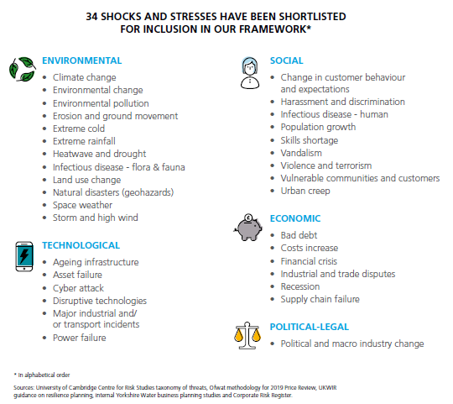

## Line of sight

We recognise the need to develop our PR19 approach in this area to include both financial and corporate areas along with operational resilience. We propose to develop our approach in this area to ensure that we can clearly show a line of sight between risks to resilience, planned mitigations, package of outcomes and corporate governance across the business.

## Assurance

It is important that as part of this work we establish and implement processes in line with both best practice and the wider water industry approach. We recognise the importance of creating and implementing processes which are consistently and robustly followed and therefore propose to create an assurance and governance framework to ensure this is the case over the short, medium and long term. This is likely to include:

* + 1. Technical auditor
    2. Financial auditor
    3. BS65000 Audits
    4. Internal audits, in line with BS9001 and ISO14001

## How are we going to get there

Our approach will need to ensure that it is in line with current best practice, have a view of future developments in this area and be in line with others in the utility industry, particularly in the water production and supply area.

We are proposing to work closely with other water companies in progressing this work and creating a common approach for the industry. This will focus on water only companies but will be interlinked, via WaterUK, with the water & sewerage companies to ensure that the approach is in line with the wider industry.

We have had initial conversations around a collaborative approach which includes SES Water and Bristol Water, with a future ambition of also including Affinity and SE Water. This will give rise to a sector wide group focused on establishing a common approach for resilience.

We are also intending to participate in the WaterUK water & waste water resilience action group.

We are already active members of UKWIR which will be developing some research projects in this area. We also intend on working with the following organisations to develop our understanding, approach and future actions in the resilience area:

* Cabinet Office Guidance
* Latest academic thinking – including the Stockholm Resilience Institute
* LRF standards and best practice
* Established best practice at other UK water companies
* International experience specifically via IWA
* Smart Cities Initiative
* Cranfield university and other universities where appropriate.
* International water and utility companies.
* External resilience approaches form outside the utility sector.
* DWI, Compliance with NIS directive

## Future plans

We will need to establish a forward looking future focused view of resilience which looks at both the 5-year AMP investment periods and the longer-term business requirements. Many of the issues we are facing as an industry are long term with risks and impacts which may extend far into the future.

We intend to come up with a resilience approach which identifies risks and mitigations over multiple timelines to evaluate the requirements of the business over the short, medium and long term.

## Project plan

|  |  |  |  |  |  |  |  |  |
| --- | --- | --- | --- | --- | --- | --- | --- | --- |
| **Systems Based Approach to Resilience** | | | | | | | | |
| Themes | Identify & Review Systems | Maturity  Assessment | Interdependences | 4R’s Assessment | Identify Shocks & Stresses | Line of Sight | Assurance | Working Group |
| Outcomes | Identify the number of systems which are present within PW and segregate into operational, financial and corporate resilience | Maturity grading of each system in terms of Resilience | Understand which systems are interdependent and how this manifests itself | How is the system resilient, follow the 4R’s approach to mitigating resilient issues | Know the shocks and stresses which might effect a system | Clearly show a line of sight between risks to resilience, planned mitigations, package of outcomes and corporate governance across the business. | Systems based approach which is consistent and in line with industry best practice | A sector wide common approach to resilience |
| Questions | What defines an independent system? | How mature is the understanding of the systems in terms of resilience? | Which other systems affect or are affected by each individual system? | How can the resilience be improved by implementing the 4R steps? | What are the shocks which might effect a system? | How does the resilience status of systems integrate into company performance? | Are there processes and checks in place to ensure the approach aligns with best practice? | How are others implementing a systems-based approach to resilience? |
| In which area, operational, financial or corporate does the system exist? | What gaps/deficiencies in understanding exist? | How do the different system affect each other? | Is the mitigation following the 4R’s hierarchy of mitigations? | What are the stresses which might effect a system? | How do risks link to planned mitigation? | Are the process being consistently and robustly followed? | What is best practice in this area? |
| Are all areas of the business covered by a system? |  |  | Are the mitigations identified effective in improving resilience? | What are the impacts of these shocks and stresses? | How do outcomes relate to resilience risks? | Is there an effective systems-based approach implemented? | How is research driving improvements in this area and what is the future approach? |
| Alignment with Yorkshire and other WOC’s approach? |  |  |  |  | How does corporate governance clearly demonstrate links to resilience risks? |  | Are we aligned with other WoC’’s in our approach? |
| Key Benefits | Understand the distinct systems and in which area each system exists | Understanding of current maturity level and any gaps | Understand the effects of one system on another and vice versa | Improved resilience of each system by identifying and implementing mitigation | Understand where the risks are to a system | Understanding the link between resilience and the performance of the company including ODI measurements | Assurance that the company has achieved a consistent and integrated systems-based approach to resilience | External view of what others are doing on resilience and how best practice is developing. |
| Allow for maturity and interdependencies to be assessed | Identification of where further work needs to be completed | Understand where multiple system may affect other systems | Understand effectiveness of mitigation measures | Understand the impacts of these risks |  |  | Ensuring that we are aligned with other similar organisations in our approach |

## Programme (indicative)

